System REQUIREMENTS SPECIFICATION
for
ECMS – SYSTEM ADMINSTRATION

Release No 1.0 – March 2021

document identification no 3 char SYS ID/ DOC CODE /NN/ V M.n)  for details refer to document mgmt stds | document title | status  (draft/ released ) | date of release | pages
ECMS /SRS/01/V1.0 | System Requirement Specifications For ECMS System administration | Draft | 03.2021 | 33

 | role in the project | Name | signature | date  (dd-mm-yy)
Authors | Technical Team | Shrinivas Udagatti  Alvin Ian P Paule  Ramoji Lokam  Shubham Sharma
Reviewers | Project Lead | Sujit Patra
Approver | Project Manager | Raghavan Jaganathan

Endorsement by System Owner (internal)
 | Name | designation | signature | date  (dd-mm-yy)
Endorsed by System Owner | Chiew Lan Tan | Senior Director

release history
Release Number | associated change request number | Date (mm,yyyy) | Brief Summary of changes | Author
1.0 |  | 03.2021

Table of Contents
Table of Contents 3
Introduction 4
A. Definitions and Abbreviations 4
B. References 6
Audit Trail Functional Requirements 7
1. Audit Trail Overview 7
1.1 Audit Trail Data Collector 7
1.2 Audit Type 7
1.3 Viewing Audit Trail 8
1.4 Audit Requirement 9
1.5 Use Case Diagram for Audit Data Collector and Audit Viewing 13
Code Maintenance Functional Requirements 14
2. Code Maintenance Overview 14
2.1 Code Maintenance to create, update, view. 14
2.2 Process Flow for Code Maintenance (Generic) 15
2.3 Use Case Diagram for Code maintenance to create/update and view. 18
Reset Password Functional Requirements 19
3. Reset Password Overview 19
3.1 Process Flow for Reset Password (Generic) 19
3.2 Use case for Reset Password. 20
Notice and Update Functional Requirements 21
4. Notice and Update Overview 21
4.1 Process Flow for Notice and Update (Generic) 22
4.2 Use case for Notice and Update. 23
Resource Management FUNCTIONAL REQUIREMENTS 24
5. RESOURCE MANAGEMENT SYSTEM OVERVIEW 24
5.1 Resource Management 24
5.2 Resource Assignment 26
5.3 Use Cases for Resource Management 30
Appendix A 32
1. Configuration blueprint (CBP) 32

Introduction
This document defines & illustrates the business requirements, process flows as well as the detailed functional requirements of eCMS System Administration module to be implemented for Department of Revenue and Customs Bhutan.

Definitions and Abbreviations
The table below lists the different acronyms and abbreviations as well as the definitions used throughout this SRS.

S/N | Abbreviations | Description
 | ACT | Authorized Compliant Trader
 | BACS | Bhutan Automated Customs System
 | BAFRA | Bhutan Agriculture and Food Regulatory Authority
 | BNB | Bhutan National Bank
 | BoB | Bank of Bhutan
 | BITS | Bhutan Integrated Tax System
 | BSTEC | Bhutan Sales Tax Exemption Certificate
 | BTC | Bhutan Tariff Classification
 | CFA | Clearing and Forwarding Agent
 | CDS | Customs Declaration System
 | CAB | Customs Act of Bhutan
 | CID | Citizens Identification Number
 | CRRB | Customs Rules and Regulations of Bhutan
 | DITT | Department of Information Technology & Telecom
 | DRC | Department of Revenue & Customs
 | eCMS | Electronic Customs Management System
 | EMS | Express Mail Service
 | FRS | Functional Requirements Specification
 | GST | Goods and Services Tax
 | IDEC | Duty Exemption Certificate
 | LTO | Liaison and Transit Office
 | LoG | Letter of Guarantee
 | LCS | Land Customs Station
 | MoEA | Ministry of Economic Affairs
 | MoHCA | Ministry of Home and Cultural Affairs
 | MoF | Ministry of Finance
 | MIS | Management Information System
 | Nu | Ngultrum
 | RMA | Royal Monetary Authority
 | RGoB | Royal Government of Bhutan
 | RRCO | Regional Revenue and Customs Office
 | RTO | Regional Trade Office
 | RAMIS | Revenue Administration Management Information System
 | SARC | South Asian Association for Regional Cooperation
 | SITA | International Aeronautical Telecommunications Society
 | SCTS | Single Customs Trade System
 | SAD | Single Administration Document
 | TPN | Taxpayer Number
 | UPU | Universal Postal Union

References
The creation of the eCMS SRS was referenced using the following documents:
- FUNCATIONAL REQUIREMENT SPECIFICATION.docx
- TECHNICAL REQUIREMENT SPECIFICATION.docx
- Bhutan eCMS Technical Proposal TECH-3.pdf
- Bhutan eCMS Technical Proposal TECH-4.pdf
- Bhutan eCMS Technical Proposal TECH-5A.pdf
- Bhutan eCMS Technical Proposal TECH-5B.pdf
- Bhutan eCMS Technical Proposal TECH-6A.pdf
- Bhutan eCMS Technical Proposal TECH-6B.pdf

Audit Trail Functional Requirements

Audit Trail Overview
The Audit Trail module is used to audit various functionalities in eCMS modules by storing the details in audit tables. The Audit Trail module contains mainly two functions. The first one is called Data Collector and the other one is called Data Viewer. All modules in eCMS will have audit logging.

The Audit Trail module is used by the system administrator (Customs) for system auditing and transaction auditing. Detailed audit tracking of each transaction can be done using the Audit Trail module. The Audit Trail module is a centralized module, and it tracks CMS audit. It is comprised of a front end for administrators to query and view a transaction audit log. At the backend all submitted transactions are audit trailed. System events like login/log out etc. will also be audited. The IP of the logged in user will also be tracked in the audit logs.

Audit Trail Data Collector

The Audit Trail Data Collector collects audit data from individual modules. Its function is to receive audit trail data from applications and then store the data in the database.

Audit Type

Audit type defined for the data collector determines if the audit is a transaction audit or a system error or system event. The following audit types are defined:
- Error – Errors & exceptions generated in the system.
- Log – This is general audit information.
- System – System events like system/instance restarts, instance shut down etc.

Viewing Audit Trail

A UI shall be provided for the system admin to view the audit logs. The UI will include filter options & search options to look for audit trail based on:

- Time period of audit
- Module
- User Id
- Audit type

The search page will have a view option to view the audit record. The user will be able to see the data as a name value pair. For e.g. Declaration data will be shown as below:

Declaration Number: DECL1000101
Declaration Type: Import
CPC Group: Import from Home
Destination Country: SG

Audit Requirement

Below is the table showing the information captured for each transaction. The business transaction reference number is the key for all transaction.
Module |  | Function | Audit Action Audit Requirement |  | Audit Description Template | System
Code  Maintenance |  | All Code tables | Create,  Update | Captured who did the change when and what change | <<code>> created  <<code>> updated  <<code>> deleted | CMS
Tariff |  | HS Code  Maintenance | Create,  Update | Captured who did the change when and what change | <<code>> created  <<code>> updated  <<code>> deleted | CMS
 |  | Tax Types | Create,  Update | Captured who did the change when and what change | <<code>> created  <<code>> updated  <<code>> deleted | CMS
 |  | Tariff Rates | Create,  Update | Captured who did the change when and what change | <<code>> created  <<code>> updated  <<code>> deleted | CMS
 |  | CPC  Maintenance  e | Create,  Update | Captured who did the change when and what change | <<code>> created  <<code>> updated  <<code>> deleted | CMS
 |  | CPC Group Maintenance  e | Create,  Update | Captured who did the change when and what change | <<code>> created  <<code>> updated  <<code>> deleted | CMS
Manifest | . | Master Manifest | Submit Approve | Captured who did the change when and what change | Master manifest submitted Master manifest approved | CMS
 | . | House Manifest | Submit  Approve  Reject | Captured who did the change when and what change | House manifest submitted.  House manifest approved.  House manifest rejected | CMS
 | . | Amendment | Modify  Cancel  Approve  Reject | Captured who did the change when and what change | <<type>> submitted.  <<type>> approved  <<type>> rejected | CMS
Declaration | . | Declaration Submission | Submit | Captured who did the change when and what change | declaration submitted | CMS
 | . | Post Entry | Submit  Approve  Reject | Captured who did the change when and what change | <<request number>> submitted.  <<request number>> approved  <<request number>>  rejected | CMS
Declaration Acceptance |  | Declaration Acceptance | Approve Reject | Captured when/who processed the declaration and what’s the output | Declaration approved Declaration rejected | CMS
Payment |  | Payment | Submit | Captured when the payment has been completed for  manifest/declaration/passenger cargo/case | Payment made | CMS
Risk |  | Declaration Risk Assessment | Processed | Captured when the risk assessment has been conducted for manifest and what’s the assessed lane | Declaration risk assessment completed | CMS
Valuation |  | Valuation  Processing | Processed | Captured when the declaration has been processed by valuation and what is the result. | Valuation completed | CMS
Inspection |  | Check-in | Submit | Captured when/who did the check in of the declaration | Check-in completed | CMS
 |  | Physical  Examination | Submit | Captured when/who did the examination of the declaration and what’s the result | Examination completed | CMS
Inter-gateway |  | Port of Entry | Submit | Captured when/who released the cargo in the port of entry | Cargo released from port of entry | CMS
 |  | Port of Exit | Submit | Captured when/who received the cargo in the port of exit | Cargo received in port of exit | CMS
Enforcement / Offence |  | Offence  Report  Submission | Submit | Captured when/who submitted the offence report | Offence report <<offence report number>> submitted | CMS
 |  | Offence  Report  Approval | Process | Captured when/who processed the offence report | Offence report <<offence report number>> approved Offence report <<offence report number>> rejected | CMS
 |  | Appeal  Submission | Submit | Captured when/who submitted the appeal | Appeal <<appeal number>> submitted | CMS
 |  | Appeal Approval | Process | Captured when/who processed the appeal | Appeal <<appeal number>> approved Appeal <<appeal number>> rejected Appeal <<appeal number>> cancelled | CMS
Passenger Cargo |  | Declaration Submission | Submit | Captured when/who submitted the declaration | Declaration submitted | CMS
 |  | Declaration Clearance | Process | Captured when the declaration been cleared | Declaration cleared | CMS
Refund |  | Refund submission | Submit | Captured when/who submitted the refund | Refund <<refund application number>> submitted | CMS
 |  | Refund Approval | Process | Captured when/who processed the refund application | Refund <<refund application number>> approved Refund <<refund application number>> rejected  Refund <<refund application number>> attend to customs | CMS

Use Case Diagram for Audit Data Collector and Audit Viewing


Perform Function
Audit Log API
User
Audit Data Collector


Search/View Logs
User
Audit Viewing

Code Maintenance Functional Requirements

Code Maintenance Overview
Code Maintenance is used to maintain the codes used in eCMS for a set of predefined code type.

Code Maintenance allows for customs officer to create/update, view the code. The code type will be preloaded from the code master. After which, the customs officers can make the necessary updates. The code entered must be unique for that code type.

Code Maintenance to create, update, view.

Code Maintenance allow for the users to view, add, update.

To add a new code, select the green, ‘+’ from the top right and user will be presented with a page (below). All the user requires to enter the code and description. The code entered must be unique for that code type.

Example, Incoterm code type cannot have duplicate ‘EXW’ code. Validation is done during save process.

Process Flow for Code Maintenance (Generic)

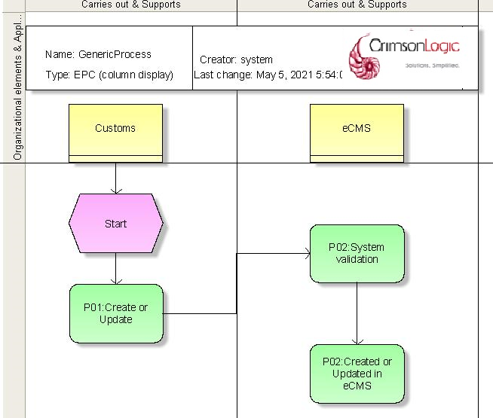

Process Steps
P01: Create or update Code Maintenance Codes
Customs Officer will create the codes for menus like Declaration, Manifest etc.
P02: System Validation
System will validate for any data issue, duplication etc.
P03: Create or Update in eCMS
The codes will be created or updated in eCMS system.

Below is the table showing the description of each code type.

Code Type |  | Requirement |  | Code Type Description Template | System
Agreement |  | Create,  Update | Create/update Agreement details and Agreement code should be unique | <<code>> created.  <<code>> updated | CMS
Aircraft |  | Create,  Update | Create/update Aircraft details and Aircraft Code should be unique | <<code>> created.  <<code>> updated | CMS
Bank |  | Create,  Update | Create/update Bank details and Bank Code should be unique | <<code>> created.  <<code>> updated | CMS
Branch |  | Create,  Update | Create/update Branch details and Branch Code should be unique | <<code>> created.  <<code>> updated | CMS
Country Group |  | Create,  Update | Create/update Country group details and Country Group Code should be unique | <<code>> created.  <<code>> updated | CMS
Country |  | Create,  Update | Create/update Country details and Country Code should be unique | <<code>> created.  <<code>> updated | CMS
Currency Code |  | Create,  Update | Create/update Currency code details and Currency code should be unique | <<code>> created.  <<code>> updated | CMS
Currency Exchange Rate | . | Create,  Update | Create/update  Currency Exchange Rate details and Currency Exchange code should be unique | <<code>> created.  <<code>> updated | CMS
Customs Office | . | Create,  Update | Create/Update Customs Office details and Customs Office code should be unique | <<code>> created.  <<code>> updated | CMS
Code Master |  | Create,  Update | Create/Update Code Master and Code Master code should be unique | <<code>> created.  <<code>> updated | CMS
Company Type |  | Create,  Update | Create/Update Company Type and Company Type code should be unique | <<code>> created.  <<code>> updated | CMS
Freight Type |  | Create,  Update | Create/Update Freight Type and Freight Type code should be unique | <<code>> created.  <<code>> updated | CMS
Document Type | . | Create,  Update | Create/Update Document Type details and Document Type code should be unique | <<code>> created.  <<code>> updated | CMS
Incoterm | . | Create,  Update | Create/Update Incoterm details and Incoterm code should be unique | <<code>> created.  <<code>> updated | CMS
Port |  | Create,  Update | Create/Update Port details and Port Code should be unique | <<code>> created.  <<code>> updated | CMS
Province |  | Create,  Update | Create/Update Province and Province code should be unique | <<code>> created.  <<code>> updated | CMS
Regime | . | Create,  Update | Create/Update Regime details and Regime code should be unique | <<code>> created.  <<code>> updated | CMS
Transit Route |  | Create,  Update | Create/Update Transit Route details and Transit Route code should be unique | <<code>> created.  <<code>> updated | CMS
Vehicle Make/Model |  | Create,  Update | Create/Update Vehicle Make/Model details and Vehicle Make/Model code should be unique | <<code>> created.  <<code>> updated | CMS
Warehouse |  | Create,  Update | Create/Update Warehouse details and Warehouse code should be unique | <<code>> created.  <<code>> updated | CMS
UOM | . | Create,  Update | Create/Update UOM details and UOM code should be unique | <<code>> created.  <<code>> updated | CMS
Offense | . | Create,  Update | Create/Update Offense details and Offense code should be unique | <<code>> created.  <<code>> updated | CMS
Duty-free entitlement |  | Create,  Update | Create/Update Duty-free entitlement details and duty-free code should be unique | <<code>> created.  <<code>> updated | CMS
Exemption Type |  | Create,  Update | Create/Update Exemption details and Exemption code should be unique | <<code>> created.  <<code>> updated | CMS

Use Case Diagram for Code maintenance to create/update and view.

Code maintenance to create/update and view

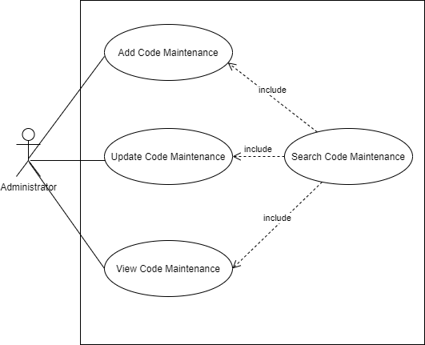

Reset Password Functional Requirements

Reset Password Overview
User can reset password in Registration module. Password automatically generated by system and notification will send to registered user email.

Process Flow for Reset Password (Generic)

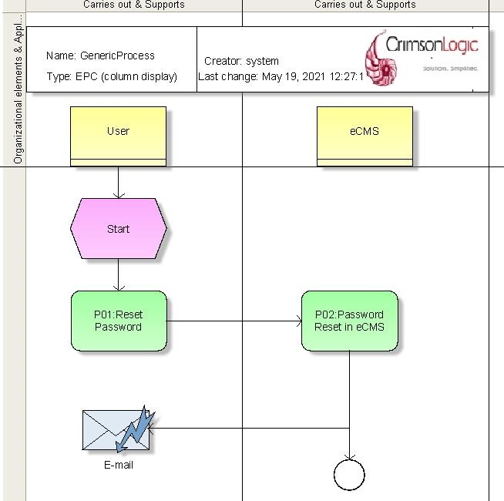

Process Steps
P01: Reset Password
System will generate the password.
P02: Update in eCMS
Password will be updated in eCMS system.

Use case for Reset Password.


Reset Password
System
Reset Password

Notice and Update Functional Requirements

Notice and Update Overview
Admin will create or Update Notice/News under System Admin Module, Once Created/Updated Notice/News will publish on eCMS portal, Users can view the published notice details.

Process Flow for Notice and Update (Generic)
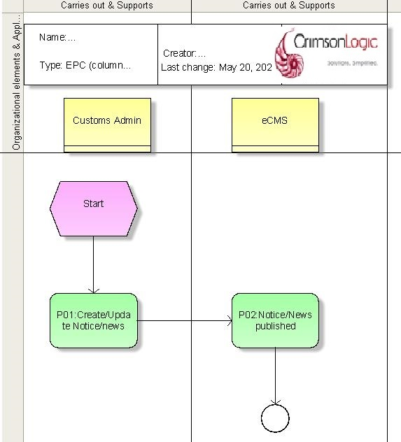

Process Steps
P01: Notice and Update Create
Admin will create/update notice/news to be published in customs site.
System will allow option to upload documents (i.e. pdf) and configure URL to view from the “notice and update” screen.

P02: Published in eCMS Homepage
Notice/News published on eCMS system Home Page. Notice will be loaded latest record on the top.

Use case for Notice and Update.
Notice and Update


Create Notice
Update Notice
Admin
Search Notice
View Published News



User

Resource Management FUNCTIONAL REQUIREMENTS

RESOURCE MANAGEMENT SYSTEM OVERVIEW
CMS use the resource management to assign officers to perform certain business functions like document verification, inspection on a specific declaration etc. The assignment is linked to a specific business transaction. The manager/supervisor of the customs office will configure resource management and can manually assign officers to task.

Resource Management
The setup for customs Admin and supervisor includes the following:
- Calendar year configuration
- Work shift assignment
- Setup vacation period of custom officers
- Task Configuration
- Pending tasks

Calendar Year Configuration

In the calendar year configuration, there are 4 tabs which requires setup:
- Calendar
  - Setup for calendar year.

- Work week
  - Setup of office hours for each day of the week.

- Work Shifts
  - Working shifts
  - Each custom officer is assigned a work shift when on duty.

- Holidays
  - Setup for eCMS to recognize public holidays

Work Shift Assignment

This setup the custom officer’s “work shift” and the start and end date of the work shift assignment.

Here are the fields needs to be setup:
- User ID – custom office user id. This is the ID which has been setup in the Registration-CMS User.
- From Date and To Date – the start and end of the configured work shift.
- Shift Name – This is the shift defined during the setup of the calendar.
- Active – it is valid.

Setup of vacation period of custom officers

All custom office needs to setup the vacation period so eCMS assignment engine will know whether an officer is present and can be assignment with new tasks.

Here are the fields needs to be setup:
- User ID – custom office user id.
- From Date and to date - Start and end date of vacation.
- Remark - description.
- Active – value for eCMS assignment engine to know whether custom office is on vacation.

Task Configuration

This is the setup of the task and the roles of the assigned modules.

Here are the fields needs to be setup:
- Task code – task code, unique.
- Task Name – Description of the task
- Module – Module for this task.
- Role – eCMS will only display the roles which is tied to the module. The role of the custom officers assigned to this task. This is tied to the CMS user’s role.
- Party – once set, it is only for the defined organization i.e. Customs.
- Customs office – once set, it is valid for the defined custom office.
- Algorithm
  - Round Robin – each office is assigned a task assigned fairly.
- Due dates (from creation date)
  - Days – number of days for the task to be completed once assigned.
  - Type of Days – Working days/Calendar days. Calendar days mean weekend included while working days is tied to the work week as setup.

Pending Tasks.

This is used for reassignment of task to another officer. Supervising officer will use the function to assign task to another officer.

Resource Assignment
There are 2 ways for resources to be assigned to a task manual and automatically.

Assignment Engine

The automatic task assignment engine will be running on a periodic time to assign newly arrived task to the available officers.

The engine will follow routing as per flow diagram below.

Process Steps
P01: Resource Identification
System will identify customs officer to be assigned for new task based on the Registration Module configuration. It also checks staff’s availability, work shift and vacation before assigning new task.
P02: Route based on Criteria and assign task
Based on the round robin algorithm system will assign the new task to the identified resource in the shift.

Design Considerations
S/N | Validation Rules
1. | A notification email will be sent supervisor when a task does not match any module defined or officer cannot be assigned to a task.

Manual Assignment

Manual assignment will be available for the supervising custom officer to assign task which is not completed within the schedule or when a task is not assigned to any officer.

Supervising officer uses the pending task menu found in Resource Management to assign task to specific custom officer.

Overdue task engine

There will be an engine which runs daily searching for open task that has past due dates. When a past due task is found, an email notification is sent to the supervisor informing about the pending task. The supervisor can take action by either reassigning to another custom officer or let is remain as it.

Process Steps
P01: Pending Task
System will check any pending task which is not actioned by the officer i.e. overdue, if yes it will send notification to supervisor.
P02: Supervisor Task Assignment
Supervisor will review internally and assign the pending and/or overdue task to available resource.

Business Rules
Refer the “System Admin CBP” excel template for business rules and user group access/role matrix.

Use Cases for Resource Management

Admin Setup and Supervisor Use Case



Admin
Create Calendar
Admin Setup and Supervisor Use Case

Update Calendar
Create Vacation
Update Vacation
Supervising Officer
Create Custom Officer Work Shift Assignment
Update Custom Officer Work Shift Assignment

View Work Shift Assignment
Setup Task Configuration
Update Task Configuration

Manual Task Assignment Use Case


Manual Task Assignment
Assign Task
Supervising Officer
Search Unassigned Task

Engine Assignment Use Case
Assign Task
Engine Assignment
System



Appendix A

Configuration blueprint (CBP)

Configuration Blueprint (CBP) for System Administration

